**Program no____3_____**

**Program Title_________LED FADING________**

**Aim**

**Hardware Required**

* Arduino Board
* blue LED

**Circuit Diagram**

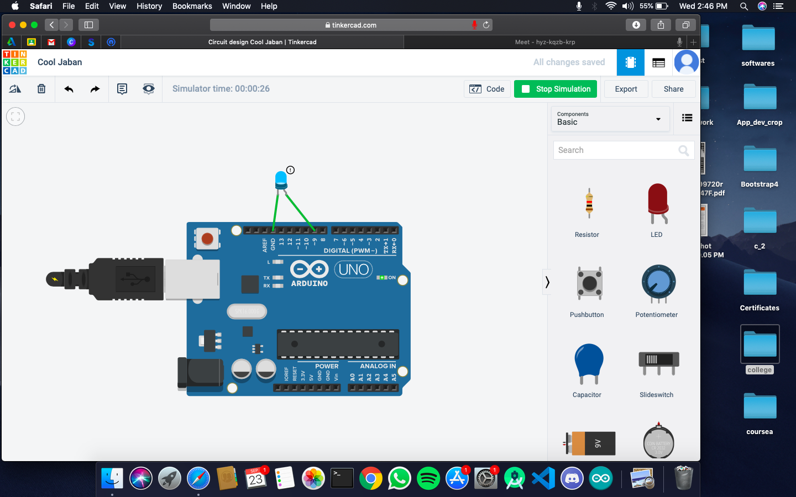

**Code:**

**int buttonpin=2;**

**int ledpin=13;**

**int buttonstate=0;**

**void setup() {**

**// put your setup code here, to run once:**

**pinMode(13,OUTPUT);**

**pinMode(2,INPUT);**

**}**

**void loop() {**

**// put your main code here, to run repeatedly:**

**buttonstate=digitalRead(buttonpin);**

**if(buttonpstate==HIGH)**

**{digitalWrite(13,HIGH);}**

**else**

**{digitalWrite(13,LOW);}**

**}**

**Observation /Output**

**the blue light will fade in and fade out.**